Home Page:

User clicks on home link after entering correct url.
The following page will be opened.
Page has information about search a job/ Post job.
How many jobs available
Can subscribe job alerts by email.
Follow us on Facebook or twitter.

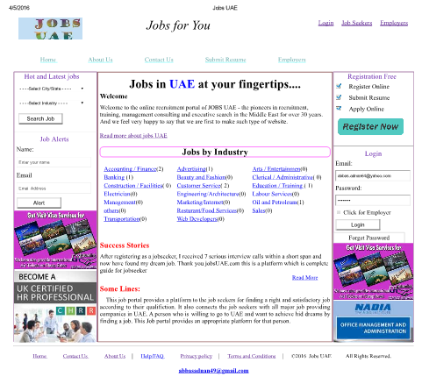

Jobseeker:

This page is design as jobseeker home page. The jobseeker can upload his resume, he can view current job list and also their details, he can apply for specific job and he can also view news updates of different categories from different channels. There are also many other options available.

Upload Resume:

This page is used to upload the jobseeker resume. To upload resume, the jobseeker must give the Resume subject and file path

Employer Registration Page:

Employer can registered here.

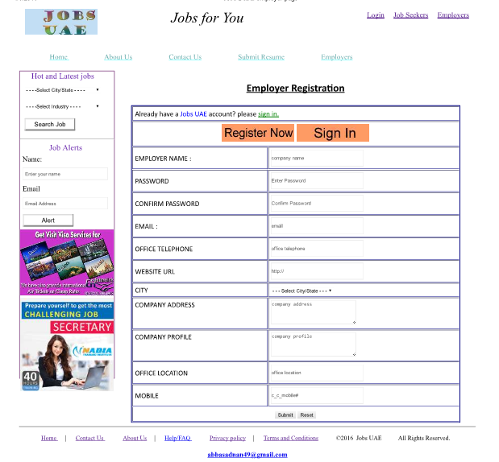

If already a member can login by just clicking on sign in button.
Gives his basic information.

Job Seeker Registration:

This page is design to make a job seeker authorized member.
Job seeker can fill this form and submit his resume and fill his basic information in the form.
Upload his picture.
If already a member can login by just clicking on sign in button.
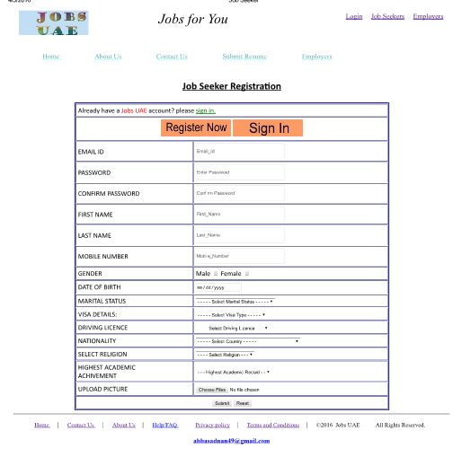
Post Job:
This page is design to post a job.
The employer can post a job if employer is sign in
The employer here fill this form and gives information about posted job
Restrictions and expiry date age limit and salary of posted job

Contact Us:
Here our cell phone no is available. If any job seeker or employer want to contact us he can contact us easily.

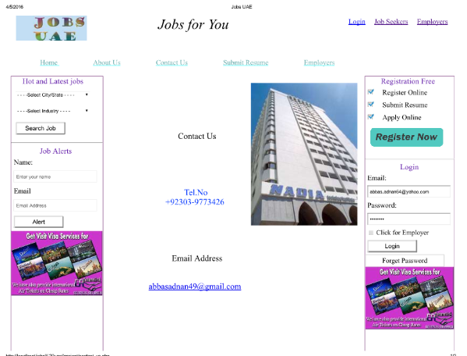

References:

http://www.nadia-me.com
this website is specially for UAE jobs and from this site I have collect important data and it give me a great help to give ideas about UAE rules registration form fill according to the requirements needed in UAE. And it,s layout is very simple and specific just for jobs.

http://dubai.dubizzle.com
dubizzle.com (the "Website") is a community content website operated by dubizzle Limitedfor designing my website I am inspire from dubbizle.com which is vey huge website and very very advance website which has many features like property nnetwork purchase and sale of vehicles job portal around the world and it has a huge data base.

http://www.glassdoor.com/
glassdoor.com is a good and simple website for job portal and from this site I also receive some ideas.
www.google.com.
I google many problems and get solution of that problem and I also many new things and ideas learnt from google.
W3school.com
W3scool.com site gives a complete tutorial about web development so I get sufficient help from this site. And this site provides a complete helping package on its platform.

